Project Report

Application for Solar Calculations
_______________________________

Submitted by
Ali Ahmed (BSSE F21-1580)
Muhammad Husnain (BSSE-1886)

Session 2021-2025

Supervised by
Dr. Muhammad Husnain


Department of Computer Science
Lahore Leads University

Application for Solar Calculations
A project submitted to the
Department of Computer Science
In
Partial Fulfillment of the Requirements for the
Bachelor’s / Master Degree in Computer Science
By
ALI AHMED
MUHAMMAD HUSNAIN

Supervisor
Dr Muhammad Husnain _______________________
Head of Department
Department of Computer Science

Dr Bilal _______________________

Mr. Adnan Majeed _______________________

COPYRIGHTS
This is to certify that the project titled “Application for Solar Calculations” is the genuine work carried out by Ali Ahmed and M. Husnain, student of BSSE of Computer Science Department, Lahore Garrison University, Lahore during the academic year 2021-2025, in partial fulfilment of the requirements for the award of the degree of Bachelor of Software Engineering and that the project has not formed the basis for the award previously of any other degree, diploma, fellowship or any other similar title.

Ali Ahmed ______________
- Husnain______________

DECLARATION
This is to declare that the project entitled “Application for Solar Calculations” is an original work done by undersigned, in partial fulfilment of the requirements for the degree “Bachelor of Science in Software Engineering” at Computer Science Department, Lahore Leads University, Lahore.
All the analysis, design and system development have been accomplished by the undersigned. Moreover, this project has not been submitted to any other college or university.

Group Members
Ali Ahmed ____________
M,Husnain_____________
Supervisor
Dr. Muhammad Hasnain _________________
Date: ________________

DEDICATION
This application is dedicated to the pioneers of solar energy who have tirelessly worked to harness the power of the sun for the betterment of humanity and the planet. Their vision and dedication have paved the way for a sustainable future.
To the scientists, engineers, and innovators who continue to push the boundaries of solar technology, your relentless pursuit of excellence and innovation inspires us all.
To the educators and advocates who spread awareness and knowledge about solar energy, your efforts are invaluable in fostering a culture of sustainability and environmental stewardship.
Lastly, to the users of this application, may it empower you with the tools and insights needed to make informed decisions, contribute to a greener future, and harness the limitless potential of solar energy

ACKNOWLEDGEMENTS
First of all, we both are thankful to ALLAH Almighty who keeps us perseverance on the path of hard work. We have taken efforts in our Final Year Project. However, it would never been possible without participation and contribution of so many individual who helped us in this project by spending their precious time. We sincerely appreciate and acknowledge the part those individuals played in the completion of our project and would like to extend our sincere thanks to all of them.
Secondly, with deep reverence our Parents who all always supported us morally, financially and showed their generous love and care though out the entire period. We feel highly oblige to thank all the faculty of computer science who shared their knowledge with us.
Last but not the least, we would like to express our special gratitude and thanks to our project supervisor Dr. Muhammad Husnain for giving us such attention and time. He proved himself as a committed project supervisor and he is a constant source of inspiration.
Table of Contents
Table of Contents
Chapter 1 13
Introduction 13
Chapter 2 14
LITERATURE REVIEW 14
2.1 Comparative/Competitive Analysis 14
2.2 Significance of study 15
Chapter 3 16
PROBLEM DEFINITION 16
3.1 Proposed Solution 16
Chapter 4 17
SOFTWARE REQUIREMENT SPECIFICATION 17
4.1 Introduction 17
4.2 Overall Description 18
4.3 External Interface Requirements 21
4.4 Functional Requirements 24
4.5 Other Nonfunctional Requirements 25
Chapter 5 28
METHODOLOGY 28
5.1 Tools: 28
5.2 Software Specifications: 28
5.3 Hardware Specifications: 31
Chapter 6 32
DETAILED DESIGN AND ARCHITECTURE 32
6.1 System Architecture 32
6.2 DETAILED SYSTEM DESING 32
Chapter 7 40
IMPLEMENTATION AND TESTING 40
7.1 Project Management 40
7.2 Responsibilities and Roles 40
7.3 Risk Management 41
7.2 Implementation 41
7.2.1 Login 41
7.3 Information Management 42
7.3.1 Implementation 42
Information Management 42
7.4 Development 42
7.4.1 Objectives 42
7.5 Tools 42
7.5.1 Software Specifications 43
7.5.2 Hardware Specifications 44
7.6 Testing 45
7.6.1 Functional or Black Box Testing 45
7.6.2 White Box Testing: 45
7.6.3 Unit Testing 46
7.7 Test Cases 46
7.7.1 User Login 46
7.7.3 AC System with Backup or without Backup 48
7.7.4 DC System with Backup or without Backup 49
Test-Case Results 50
Chapter 8 51
RESULTS AND DISCUSSION 51
Splash screen 51
Sign Up 52
Login 53
Home Screen 54
Get Started Screen 55
Choose Backup Screen 56
Add Device Screen 57
Result Screen 58
Chapter 9 59
CONCLUSION AND FUTURE WORK 59
REFERENCES 59

List of Tables
Table 5.1 software specification 28
Table 5.2 Hardware Specification 31
Table 7.1 Responsibility and roles 40
Table 7.2 Risk Management 41
Table 7.3 Software Specifications 43
Table 7.4 Hardware Specifications 44
Table 7.5 User Login 46
Table 7.6 user profile 47
Table 7.7 AC system with backup or without Backup 48
Table 7.8 DC system with backup or without Backup 49
Table 7.9 Test Case Results 50

List of Figures
Figure 6.1 Activity Diagram 35
Figure 6.2 Use Case Diagram 36
Figure 6.3 Work Flow Diagram 38
Figure 6.4 Data Flow Diagram 38
Figure 6.5 ER Diagram 39
Figure 8.1 Splash Screen 51
Figure 8.2 Sign up Screen 52
Figure 8.3 Login Screen 53
Figure 8.4 Home Screen 54
Figure 8.5 Get Started Screen 55
Figure 8.6 Choose Backup 56
Figure 8.7 Add Device 57
Figure 8.8 Result Screen 58

List of Abbreviation

SDK | Software Development Kit
UML | Unified Modelling Language
APK | Android Application Package
APP | Application
SRS | System Requirement Specification
API | Application Program Interface
IDE | Integrated Development Environment

ABSTRACT
Abstraction of application of solar calculations refers to the process of simplifying and generalizing complex solar calculation methods to make them more accessible and applicable to a wide range of situations. The "Application for Solar Calculations" is a cutting-edge software solution designed to optimize solar energy utilization through a synergistic blend of diverse technologies. This Application provides user-friendly interfaces to comprehensive solar calculations for both residential and commercial users. Key features of the application include real-time solar prediction, allowing individuals to assess the feasibility of solar installations, estimate energy savings, and optimize system configurations.

Chapter 1

Introduction

The whole world is suffering from energy crisis due to lack of energy resources and increase in population, its influence in Pakistan is more Due to population growth and lack of new resources. Everybody is dealing with this crisis because the government has not taken any concrete steps for the past four decades.
Because of this, either a user use UPS or generator that is expensive. Because the Ups use WAPDA electricity and stores the backup. It is impossible to avoid load-shedding when WAPDA is closed and the losses during conversion is 40% and because of that the electricity bill is high. If we talk about generator the cost of maintenance and oil is very high and Causes pollution. Compared to both of them solar system is better and environment friendly. Now-a-days people are move on to latest and renewable resources and Solar Energy is a truly renewable energy source.
To strive towards a 100% renewable energy future by educating users about the environmental and financial benefits of solar power. Most of the people use solar system because it’s life more than 15 years and it is better among others. Firstly, when people move on to Solar system. Mostly, they do not have enough information & no one can guide them properly. Due to miss guidance, they face some difficulties during this process. Hence, our Solar-Solutions (SS) application help those who are naive and sophisticated.
In particular, user found it hard to find the all-important information on the cost, savings, energy and environmental benefits of solar power. The calculators that were online delivered some of this information, however, most produced biased and unrealistic results in the hope of generating new business. No one calculator was able to incorporate all of the different variables and other important factors including: daily supply charge, the effect of shading and the new solar frontier, battery storage. And so Solar Calculator was born to answer all of these questions and many more and provide an independent, reliable and accurate resource for anyone wanting to go solar system.
Solar-Solution (SS) will become the best app for the mobile app’s users. It gives a lot of benefits to the public.
System will generate optimal results according to the requirements by user.
System will also provide out-put device selection for user what they want to implement in the system.
Safety Factor Radiations, DOD, Efficiencies of output devices.
Selection of System Type that want to design. Device selection with complete details with Defaults (Backup Hours, Power, Volts, Amp, Efficiency).

Chapter 2

LITERATURE REVIEW
When we talk about the background work similar to our purposed work, we found that many researchers have done similar type of work in different fields there are many web sites which are performing similar calculations but we found that their UI is not suitable for the common user they target the professional persons or technical. When we talk about android applications that can be found at google app store, we found that their work is limited they did not cover all the aspects of the solar system installations. As compare to previous task our task is specifically for android market because today every single person is using android phones and used different applications in daily use so our work will help specially a common user.

2.1 Comparative/Competitive Analysis

There are different Applications are available that are less likely related to our Study.
- Solar calculator By Fver-great production
- Solar Calculator by Malvern Yap Indian.
- Solar Calculator By prosper India
Their work is very limited. They perform simple Calculations. Results are in between Loads and Watts. UI of their applications are not user friendly.
Our study involves detailed system calculations for Off Grid systems.
Our generated Results will be more specify and easy to understand. We give optimal solution by recommending Inverter, Batteries and Solar panels according to their requirements. Our work is for both naive and educated user.

2.2 Significance of study

Solar-Solutions (SS) app was born to answer all of these questions and many more and provide an independent, reliable and accurate resource for anyone wanting to go solar system. Solar-Solutions (SS) application help those who are naïve and sophisticated. In particular, user found it hard to find the all-important information on the cost, savings, energy and environmental benefits of solar power. We give optimal solution by recommending Inverter, Batteries and Solar panels according to their result. Our Solar-Solutions (SS) app, is independent and free to use; it assists people in making an informed decision about solar rooftop panels, inverter and batteries. In fact, we provide calculators for all forms of solar systems including: off grid solar systems. Solar-Solution (SS) is our resource for everything we need to know about weighing up, and then converting to solar power.
Sun Energy
Optimizing sun Panel performance: solar calculations help determine the premiere placement and orientation of solar panels to maximize energy capture all through the day and throughout seasons. this can significantly decorate the efficiency of sun electricity systems.

Environmental Effect
Reducing Carbon Footprint: through optimizing solar panel performance and increasing the adoption of solar strength, the reliance on fossil fuels is reduced, main to a extensive lower in greenhouse fuel emissions.
Sustainable development: sun panel calculations make a contribution to the layout of sustainable strength systems that help worldwide efforts to fight climate exchange and decrease environmental degradation.

Chapter 3

PROBLEM DEFINITION
When a common man moves towards the installations solar system, he has to face several problem:
- unavailability of solar calculation
- wrong solar calculations
- non-supply of accurate information from the vendors
These problems typically require knowledge of astronomy, mathematics, and physics, and are often solved using a combination of theoretical calculations and empirical data. Tools and software like Solar Position and Intensity models, solar calculators, and astronomical algorithms are commonly used to perform these calculations.

3.1 Proposed Solution

We will make such an application that will provide complete guidance to the common man or the businessman about the solar calculations and solar system components. We will make a mobile application that will be available for all mobile platforms like android etc.

Chapter 4

SOFTWARE REQUIREMENT SPECIFICATION

4.1 Introduction

4.1.1 Purpose
The venture aims to combat Pakistan's power crisis with the aid of promoting solar strength adoption and imparting environmental and monetary blessings over conventional energy assets like turbines and subsystems. Its number one aim is consumer training, filling statistics gaps concerning sun electricity's fees, financial savings, and environmental impacts. via an unbiased solar calculator app, the venture seeks to offer unbiased and accurate information to customers, incorporating variables like each day costs, shading outcomes, and battery garage. Through improving person enjoy with a user-friendly cell app, its objectives to empower users to make informed selections approximately sun power implementation. detailed machine information, along with greatest configurations and device information, will facilitate customers' transition closer to sustainable strength solutions. ordinary, the challenge endeavors to make contributions to Pakistan's sustainable power destiny by advocating for and facilitating the widespread adoption of sun power.

4.1.2 Intended Audience and Reading Suggestions
- Explore the challenges posed by the current energy crisis in Pakistan
- Understand the benefits of solar power as a renewable energy solution
- Learn about the environmental and financial implications of traditional energy sources
- Investigate the economic feasibility of solar power systems
- Delve into the technical aspects of solar energy implementation
- Examine resources related to energy policy in Pakistan
- Discover technological advancements in solar energy
- Review case studies of successful solar power projects
- Engage with topics surrounding energy sustainability and environmental conservation in Pakistan

4.1.3 Product Scope
The project scope encompasses numerous key objectives geared toward selling the adoption of solar power answers in Pakistan. It’s includes the improvement of comprehensive instructional materials to tell customers about the environmental and economic advantages of sun power as compared to standard energy assets like generators and unstructured. moreover, a user-friendly hybrid cellular software might be designed and applied to function a solar calculator, enabling users to calculate fees, financial savings, and environmental benefits associated with sun strength installation. Integration of reliable information sources is critical to make sure the accuracy of calculations, and customized consequences may be supplied to users considering different factors consisting of shading effects and battery garage alternatives. the point of interest will be on enhancing the user experience via intuitive design and interactive capabilities in the software. Technical help could be provided to customers, and regular updates may be provided to make certain the application's capability and compatibility with evolving mobile systems. Promotional campaigns will be conducted to elevate attention and encourage adoption of solar electricity answers, focused on house owners, agencies, policymakers, and environmental agencies. continuous tracking of person engagement and remarks will tell improvements to the application, at the same time as periodic reviews will assess its effect and effectiveness in attaining mission objectives.

4.2 Overall Description
Product Perspective
The project objectives to introduce a complete sun calculator utility in the renewable electricity sector in Pakistan. It stands as a pivotal tool for users, bridging the gap between traditional electricity assets and sustainable options like solar strength. This software will serve as an impartial resource, providing correct and unbiased data concerning the costs, financial savings, and environmental benefits of solar energy systems. in the context of current power solutions which includes turbines and structures, the solar calculator gives an awesome benefit by means of supplying personalized effects based on character user necessities. From a technological viewpoint, the utility represents a tremendous advancement, leveraging cell generation to empower users in making knowledgeable decisions about sun power adoption. moreover, the task integrates with broader efforts to deal with Pakistan's strength crisis by promoting renewable power answers and reducing reliance on non-renewable sources. As a part of the renewable electricity landscape, the solar calculator utility fills an important area of interest, facilitating the transition closer to a greater sustainable energy future in Pakistan.
• provide informative substances explaining the blessings of sun electricity.
• provide guides on sun strength implementation, gadget kinds, and components.
• expand a person-pleasant cell application for sun calculations.
• permit customers to calculate the prices, savings, and environmental advantages of power.
• acquire reliable facts sources for correct calculations.
• Validate the accuracy of records furnished by using the solar calculator.
• provide personalized effects primarily based on person input and possibilities.
• do not forget variables like shading outcomes and battery garage alternatives.
• make certain intuitive design and interactive factors in the software.
• provide a continuing person enjoy for clean navigation and engagement.
• offer technical aid for customers to troubleshoot problems.
• frequently replace the application to improve functionality and compatibility.
User Classes and Characteristics
- Inquisitive about lowering electricity bills and environmental impact.
- are looking for data on the advantages and feasibility of putting in sun energy structures.
- Value consumer-pleasant gear to calculate costs and savings.
- Interested in fee-effective electricity solutions to reduce operational prices.
- Require unique statistics at the economic benefits and go back on investment of sun electricity.
- Trying to find scalable solutions tailor-made to their electricity consumption desires.
- concerned with addressing Pakistan's electricity disaster and selling renewable energy adoption.
- Require dependable facts and resources to formulate rules supporting solar electricity tasks.
- The Value of equipment that facilitates knowledgeable choice-making and policy improvement.
- Advocate for sustainable electricity solutions to mitigate environmental impact.
- Searching for accurate records at the environmental advantages and carbon footprint discount associated with sun electricity.
- Cost tools that empower people and groups to make contributions to environmental conservation efforts.
- Curious about renewable electricity alternatives and their ability benefits.
- Seeking handy resources to recognize the advantages of sun electricity and its software in regular lifestyles.
- Price academic substances and tools that facilitate learning and choice-making regarding energy picks.
Operating Environment
The running surroundings of the assignment is characterized by way of several key elements. first off, it operates inside the digital landscape, utilizing mobile packages and online platforms to attain customers. This necessitates get right of entry to to the internet for customers to interact with the sun calculator application and get admission to academic assets. inside Pakistan's strength sector, the venture addresses demanding situations which includes load-shedding and reliance on non-renewable strength sources by means of selling solar strength adoption. It should navigate regulatory frameworks governing the energy area and mobile software development at the same time as doubtlessly taking advantage of government tasks helping renewable energy. fulfillment hinges on consumer engagement and adoption of the software, highlighting the significance of consumer schooling and consciousness approximately solar power. moreover, the project's effectiveness is based on the availability of technological infrastructure, such as reliable cellular networks and information servers, to supply accurate calculations and offer a continuing consumer revel in.
Design and Implementation Constraints
Technological Infrastructure Limitations:
Confined get entry to to dependable internet connectivity and technological infrastructure in sure areas of Pakistan can also restrict significant adoption and utilization of the solar calculator utility.
Regulatory Compliance:
Adherence to regulatory frameworks governing each the strength quarter and mobile application development in Pakistan poses constraints at the layout and implementation of the mission, requiring cautious navigation of criminal necessities.
Data Availability and Accuracy:
Availability and accuracy of statistics assets up-to-date solar power prices and savings, and environmental effects may also pose constraints at the reliability and effectiveness of the sun calculus-to-dater software, specifically if comprehensive and information are not quite simply on hand.
User Education and Awareness:
Limited cognizance and knowledge of sun electricity most of the target user businesses might also constrain the venture's effectiveness, necessitating additional efforts in consumer schooling and outreach to overcome expertise gaps and misconceptions.
User Documentation
Welcome to solar-answer (SS), your comprehensive guide to harnessing the power of sun energy. With the growing strength disaster globally and in particular in regions like Pakistan, where populace growth and resource scarcity exacerbate the trouble, it has come to be imperative to undertake renewable energy solutions like sun strength. SS ambitions to empower users with the understanding and equipment vital to make informed choices approximately transitioning to sun power.

Assumptions and Dependencies
The introduction assumes that the strength crisis in Pakistan is exacerbated by using populace boom, leading to extended strength demand and stress on present resources.
it's far assumed that the lack of concrete steps taken through the government in Pakistan over the past 4 a long time has contributed extensively to the electricity crisis, growing a dependency on alternative power resources like upstand generators.
The introduction highlights the assumption that the fee of the use of user mills, which include upkeep and gas fees, is extensive and unsustainable for many individuals or companies.
it is assumed that there is a growing consciousness and subject approximately the environmental impact of traditional power resources like generators, leading to a shift closer to renewable power answers like solar electricity.

4.3 External Interface Requirements
User Interfaces
Dashboard:
Upon successful login, users are directed to the dashboard.
The dashboard provides an overview of available features and options.
It may include shortcuts to key sections like Solar Calculator, Output Device Selection, Help/Support, etc.
Solar Calculator:
This interface allows users to input various parameters for calculating the feasibility of solar energy.
Fields for entering location, energy consumption, shading details, system type selection, etc.
Results section displaying cost estimates, savings, energy production, and environmental benefits.
Output Device Selection:
Here, users can choose output devices based on their preferences and requirements.
Options presented with detailed information such as backup hours, power, volts, amps, efficiency, etc.
Ability to select and add devices to the overall system design.
Help/Support Section:
This interface provides access to user support and assistance.
Options to access FAQs, contact support, submit feedback, etc.
Resources for troubleshooting common issues or queries.
Settings:
This section allows users to customize app preferences and settings.
Options for language preferences, units of measurement, notification settings, etc.
Ability to edit profile information or change account settings.
Hardware Interfaces
Solar Panels
Battery Storage Systems
Inverters
Charge Controllers
Electrical Wiring and Connections
Software Interfaces
Operating System (Android)
Solar-Solution (SS) Mobile Application
Database Management System (for storing user data and preferences)
APIs for accessing User Signup data and Login Data about users.
Integration with third-party tools or calculators for accurate calculations and analysis
Communications Interfaces
User Authentication:
Secure user authentication and registration process to access the application's features.
Mode Selection:
Option for users to choose between AC and DC mode based on their system requirements.
System Type Selection:
Selection of system types including AC with Backup, AC without Backup, DC with Backup, and DC without Backup.
Device Selection:
Comprehensive list of common appliances for users to select along with quantities for accurate load calculation.
Backup Hours Input:
Ability for users to input backup hours per day or per week to customize the system according to their needs.
Optimal Results Generation:
Technology of ultimate outcomes based on person necessities along with tips for inverter, battery, fee controller, and sun panels.
Detailed Component Information:
Specified data furnished for every factor consisting of specifications, efficiencies, and safety elements.
Calculation Module:
Calculation module to compute load, inverter requirements, battery capability, sun panel wattage, charge controller specs, etc.
Offline Capability:
Offline functionality allowing users to use the utility without requiring a web connection.
Cross-Platform Compatibility:
Compatibility with a couple of systems such as Android, iOS, and windows for full-size accessibility.
User-Friendly Interface:
Intuitive and person-pleasant interface designed to cater to each newbie and experienced customers.
Installation Packages:
Provision of installation applications for all important cell working structures for easy set up on various gadgets.
Automatic Updates:
computerized updates mechanism to make sure users have access to the modern-day functions, improvements, and malicious program fixes.
Description and Priority
The solar answers utility for solar Calculations pursuits to offer customers with a comprehensive device for estimating, designing, and implementing sun strength structures. It offers a consumer-friendly interface where customers can enter their necessities and get hold of most reliable recommendations for solar additives including inverters, batteries, fee controllers, and solar panels. The utility caters to both AC and DC systems, allowing customers to pick the correct device type based on their desires. With capabilities like tool choice, backup hours input, and designated issue statistics, SS ensures correct and green calculations for customers, whether or not they may be beginner or experienced in solar electricity structures.
Priority:
User Authentication: High priority to ensure secure access to the application's features and protect user data.
Stimulus/Response Sequences
Stimulus: User launches the Solar Solutions (SS) Application.
Response: Application displays the login/register screen.
Stimulus: User enters login credentials and taps on the login button.
Response: Application authenticates the user and directs them to the dashboard.
Stimulus: User selects the mode (AC or DC) for solar calculations.
Response: Application prompts the user to choose the system type (AC with Backup, AC without Backup, DC with Backup, DC without Backup).
Stimulus: User selects the system type and proceeds to device selection.
Response: Application presents a list of common appliances along with fields to input quantities.
Stimulus: User inputs the quantities of appliances and backup hours per day/week.
Response: Application calculates the load, inverter requirements, battery capacity, solar panel wattage, and charge controller specifications.
Stimulus: User confirms the input parameters and proceeds to view results.
Response: Application generates optimal recommendations for solar components based on the user's requirements.
Stimulus: User taps on a specific component (e.g., inverter) to view detailed information.
Response: Application displays detailed specifications and information for the selected component.

4.4 Functional Requirements

User Authentication
Mode Selection
System Type Selection
Device Selection
Backup Hours Input
Optimal Results Generation
Detailed Component Information
Calculation Module
Offline Capability
Cross-Platform Compatibility
User-Friendly Interface
Updates

4.5 Other Nonfunctional Requirements
Performance Requirements
The performance necessities for the sun answers (SS) Hybrid software are crucial for ensuring a clean and efficient person experience. The software must reply directly to consumer inputs, preserving minimal latency to make sure seamless interaction. complex calculations, vital for generating most suitable tips, ought to be completed hastily to offer well timed results. moreover, the offline capability of the application is paramount, allowing users to get admission to vital functions and records even without an internet connection. move-platform compatibility is critical, ensuring steady performance across distinctive cell structures and gadgets. as the person base grows, the software has to scale correctly to deal with multiplied workload without compromising overall performance. efficient useful resource usage is fundamental, optimizing CPU, reminiscence, and battery utilization to enhance standard performance at the same time as minimizing useful resource intake. sturdy mistakes dealing with mechanisms have to be in place to deal with any problems directly, ensuring a dependable and stable user experience. security measures ought to be sturdy, safeguarding user facts and privacy in opposition to unauthorized get entry to or breaches. Compatibility with older gadgets is likewise crucial, ensuring that customers with older hardware can nevertheless get admission to and make use of the software without overall performance degradation. ultimately, support for computerized updates guarantees that users have get entry to to the cutting-edge capabilities and enhancements without manual intervention, enhancing the overall usability.

Safety Requirements
Data Security: The utility should enforce robust encryption protocols to ensure the safety and confidentiality of user records, shielding it from unauthorized get admission to or breaches.
User Privacy: Measures must be in location to protect consumer privacy, making sure that personal data isn't always shared or accessed without specific consent.
Error Handling: The utility must have effective error dealing with mechanisms to prevent gadget crashes or data corruption, minimizing the hazard of person frustration or loss of data.
Backup and Recovery: Normal statistics backups should be performed to prevent facts loss inside the event of system screw ups or crashes, with efficient restoration tactics in region to repair statistics to its unique kingdom.
User Authentication: Study authentication mechanisms need to be carried out to affirm the identity of users and prevent unauthorized get admission to sensitive features or records.
Device Compatibility: The utility must be well suited with a wide range of cell devices and running structures, making sure that users can get entry to its functions properly and reliably irrespective of their tool.
Security Updates: Ordinary security updates need to be furnished to patch vulnerabilities and guard the utility from rising threats, ensuring the safety and integrity of person statistics.
Emergency Notifications: In the occasion of gadget failures or protection breaches, the application must be capable of notify users promptly, permitting them to take suitable action to defend their records and privateness.
Compliance with Regulations: The application must comply with relevant data protection regulations and standards to ensure the safety and legality of its operations, protecting both users and the organization from legal liabilities.
User Education: Good enough consumer training and education must be supplied to make sure that users are aware about ability dangers and safety measures while the use of the software, empowering them to make informed selections and mitigate capacity threats.
Security Requirements
Authentication: The application should hire sturdy authentication methods, including password hashing to ensure that simplest authorized users can get right of entry to sensitive features and records.
Authorization: Get entry to control mechanisms need to be carried out to restrict consumer get entry to to particular functionalities primarily based on their roles and privileges, stopping unauthorized actions.
Secure Storage: User data stored locally or on servers must be securely encrypted and stored in compliance with relevant data protection regulations to prevent unauthorized access or data breaches.
Secure Communication: Secure communication protocols, such as HTTPS, should be used to ensure the confidentiality and integrity of data exchanged between the application and external servers or APIs.
Session Management: Robust session management mechanisms should be implemented to prevent session hijacking or fixation attacks, ensuring that sessions expire after a certain period of inactivity.
Input Validation: Input validation should be enforced to prevent injection attacks, such as SQL injection or cross-site scripting (XSS), by sanitizing and validating user input before processing.
Software Quality Attributes
Reliability: The application should consistently perform its intended functions accurately and reliably, minimizing the occurrence of errors or failures.
Usability: The user interface should be intuitive and easy to navigate, ensuring that users can effectively interact with the application without encountering confusion or frustration.
Performance: The application should respond promptly to user inputs and execute tasks efficiently, ensuring optimal performance even under heavy workloads or peak usage periods.
Scalability: The application should be able to accommodate a growing user base and increasing workload by scaling its resources and functionalities effectively without compromising performance.
Compatibility: The application should be compatible with a wide range of devices, operating systems, and web browsers, ensuring that users can access its features seamlessly regardless of their platform or environment.
Portability: The application should be easily deployable across different environments, platforms, and devices without requiring significant modifications or adaptations.
Flexibility: The application should be flexible and adaptable to accommodate changing user requirements, business needs, or technological advancements over time.
Testability: The application should be designed with testability in mind, allowing for comprehensive testing of its functionalities, features, and components to ensure robustness and reliability.

Chapter 5

METHODOLOGY
The methodology of solar calculations involves a series of steps to determine the amount of solar energy that can be generated by a solar panel system. Here is a comprehensive overview of the methodology:

5.1 Tools:
We have used Android Studio, Android Studio code for the development of the application. We have used the best tools and equipment for the development of the project. As Android has the biggest smart phone market. Most of the peoples are using different android smart phones. Therefore, android application development is the best choice for doing a startup. This Application can be run on Android Software version 7.0 to 13 (API 23-34). These minimum and maximum Software Development Kit Versions were used to attract more users and make the application popular and successful in maximum users. We have used Firebase authentication service for logging in to the application.

5.2 Software Specifications:

Table 5.1 software specification
Software Description | Android Application
Operating Software for Solar Calculations | Android Software 7.0 to 14 (API 23-34)
Tools used for Development | Android Studio
Languages used for Development | Flatter (DART)
Database | Firebase

In the Above Table 5.1 is representing the points as described in the following section:

Tools Used for Development: Android Studio
Android Studio:
- Integrated Development Environment (IDE):
  - Android Studio is the official IDE for Android development, providing tools for designing, coding, debugging, and testing Android applications.
  - Features: It includes an intelligent code editor, a visual layout editor, performance analysis tools, and an emulator for testing applications on virtual devices.
  - Developer Support: Offers extensive support for integrating various libraries, version control, and continuous integration.
Languages Used for Development: Flutter (Dart)
Flutter Framework:
- Flutter:
  - Cross-Platform Development: Flutter is a UI toolkit for building natively compiled applications for mobile (Android and iOS), web, and desktop from a single codebase.
  - Fast Development: Features like Hot Reload allow developers to see changes almost instantly, speeding up the development process.
  - Customizable Widgets: Provides a rich set of customizable widgets for creating beautiful user interfaces.
Dart Language:
- Dart:
  - Language Used in Flutter: Dart is an object-oriented, class-defined programming language optimized for client-side development.
  - Performance: Compiled to native code for high performance on mobile and desktop, and also supports just-in-time (JIT) compilation for fast development cycles.
  - Modern Features: Includes async/wait for asynchronous programming, a rich standard library, and sound null safety for improved reliability.

Database: Firebase
Firebase:
- Backend as a Service (BaaS):
  - Cloud Fire store: A flexible, scalable database for mobile, web, and server development from Firebase and Google Cloud Platform.
  - Real-time Data: Supports real-time synchronization, making it ideal for applications that require live updates.
  - Scalability: Automatically scales to handle large volumes of data and traffic.
  - Security: Provides robust security features, including authentic

5.3 Hardware Specifications:

Table 5.2 Hardware Specification
Hardware Description | Android Application
Ram | 1 Gigabyte  (1 GB)
Processor | 1.6 Gigahertz
Storage | 8 Gigabyte  (8 GB)

In the Above Table 5.2 is representing the points as described in the following section:
RAM: 1 Gigabyte (1 GB)
RAM (Random Access Memory) is a type of computer memory that is used to store working data and machine code currently in use. For an Android application:
1 GB of RAM indicates that the device can handle basic multitasking and run most apps, but it might struggle with heavy applications or extensive multitasking.
Performance Impact: Applications that require significant memory for data processing, gaming, or multimedia might experience slower performance or might not run as smoothly on a device with only 1 GB of RAM.
Processor: 1.6 Gigahertz
Processor speed is measured in gigahertz (GHz) and determines how many cycles per second the CPU can execute. For a device with:
Storage: 8 Gigabyte (8 GB)
Storage refers to the device’s internal capacity to store the operating system, applications, and user data.

Chapter 6

DETAILED DESIGN AND ARCHITECTURE

6.1 System Architecture
This system architecture ensures that the solar calculation application is robust, scalable, and efficient. By carefully designing each layer and integrating key components, the application can effectively serve its intended users, providing accurate solar calculations and valuable insights for solar energy projects.
As Solar Calculations is a Mobile application. There are different activities that work together to ensure better management of Solar Calculations. First of all, need to be logged in by using Firebase email authentication. After that he don’t have to enter that data. The users are now entered information according to the requirements of the system.

6.1.1 Architecture Design Approach
As we are having just completed our course so we are inexperienced as compared to market. Therefore, we have used Design Guidelines Iterative approach to design the system. It is the most inexpensive and easy approach to be used for Final Year Project. Guidelines were available for us in different forms by Software Engineering community.

6.1.2 Architecture Design
Our system consists of User- Server architecture where the data is being stored in the Firebase database. Users interact with the database by sending information and application and servers communicate for storing as. Well as fetching that information. To make the communication protocol more efficient and as simple as it can be, we used HTTP for the communication among Server-User as well as User-Server.

6.1.3 Subsystem Architecture
Data Flow Diagram is being used to define the step-by-step processes which are describing the flow of data graphically with the use of different components of the DFD diagrams.

6.2 DETAILED SYSTEM DESING
After logging in to the Application of Solar Calculations, there are two components of the system which are explained above with details that how a User can Login to the system and how the actions like performing calculations with AC or DC system with Backup or without backup for the requirements provided by the users.

6.2.1 Classification
- User is a person that calculate the solar calculations according to their requirements.
- Vendors is a group of providers that provide the services according to the requirements of the Users.

6.2.2 Definition

Solar calculations check with the systematic strategies and mathematical techniques used to decide numerous parameters and overall performance metrics related to solar power. the ones calculations are vital for know-how the position of the sun, the amount of solar radiation obtained at a specific region, and the overall performance of sun electricity structures. they're appreciably used in designing, optimizing, and assessing solar electricity installations for every residential and commercial functions.

6.2.3 Responsibilities

Sun calculations confer with the systematic techniques and mathematical strategies used to determine diverse parameters and performance metrics related to sun energy. these calculations are critical for expertise the placement of the sun, the quantity of sun radiation obtained at a selected area, and the performance of sun power systems. they're extensively utilized in designing, optimizing, and assessing solar energy installations for both residential and industrial purposes. Key elements of sun calculations consist of:

6.2.4 Constraints
Sun calculations contain numerous constraints that may impact the accuracy and effectiveness of the checks. know-how those constraints is essential for designing and optimizing solar power systems. Constraints in solar calculations span throughout geographical, meteorological, physical, technical, economic, regulatory, data, environmental, and technological factors. Addressing those constraints entails careful planning, thorough analysis, and the use of superior equipment and methodologies to optimize the performance and feasibility of sun strength systems. by using thinking about those constraints, stakeholders could make knowledgeable selections to maximize the blessings of solar energy.

6.2.5 Composition
In the context of solar calculations and solar power systems, "composition" commonly refers back to the diverse components and their arrangements within a solar power device. This entails both the hardware factors (inclusive of sun panels, inverters, batteries) and software factors (together with monitoring structures, records processing algorithms). The composition of a sun electricity device involves a harmonious integration of diverse hardware and software program additives designed to capture, convert, shop, and manipulate solar electricity successfully. each factor plays a critical role in making sure the system's average overall performance, reliability, and monetary viability. knowledge those components and their capabilities is essential for designing and optimizing sun electricity solutions

6.2.6 Uses/Interactions
The interactions within a solar power device are complex and multifaceted, involving diverse additives operating together to capture, convert, shop, and distribute solar electricity successfully. information those interactions is essential for optimizing the system's performance and ensuring its reliability. The interactions inside a solar energy gadget involve a delicate stability among taking pictures, converting, storing, and distributing solar energy. each aspect plays a critical position, and their interactions need to be cautiously controlled to ensure gold standard performance, performance, and safety. by knowledge those interactions, gadget designers and operators can optimize the device to fulfill unique energy needs and adapt to changing conditions.

6.2.7 Resources
Resources for solar calculations encompass a range of tools, datasets, software, and methodologies that facilitate accurate assessments and predictions of solar energy potential. The resources for solar calculations are diverse and include software tools, datasets, mathematical models, APIs, technical literature, and educational materials. These resources provide the necessary data, algorithms, and knowledge to accurately assess and optimize solar energy systems, ensuring efficient and effective utilization of solar power.

6.2.8 Processing
Processing in solar calculations includes a series of steps and computational techniques to appropriately verify and predict solar electricity ability and performance. Processing in solar calculations involves gathering and analyzing a diffusion of statistics to accurately expect sun strength potential and device performance. via systematically calculating sun positions, radiation degrees, shading influences, and economic elements, those techniques ensure that solar energy structures are designed and optimized for max performance and monetary viability.

6.2.9 Interface/Exports
The interface in a solar strength gadget refers back to the way thru which users engage with and control the system. this can contain hardware interfaces, software program interfaces, and communication protocols that permit tracking, control, and optimization of sun energy systems. Interfaces in a solar energy system are vital for making sure customers can effectively reveal, control, and optimize their solar strength structures. They variety from physical display panels and switches to superior net-based totally dashboards and cellular programs. effective communique interfaces make sure seamless records switch and integration with other systems, while manipulate interfaces provide customers with the potential to manage their electricity manufacturing and intake successfully. together, these interfaces contribute to the general functionality, consumer enjoy, and efficiency of sun strength structures.

6.2.10 Detailed Subsystem Design
Designing a detailed subsystem within a solar power system involves focusing on each component's specific functionalities and how they interact with one another. The detailed design of subsystems in a solar power system involves careful consideration of various components and their interactions. Each subsystem must be optimized for performance, efficiency, and reliability.
- Activity Diagram
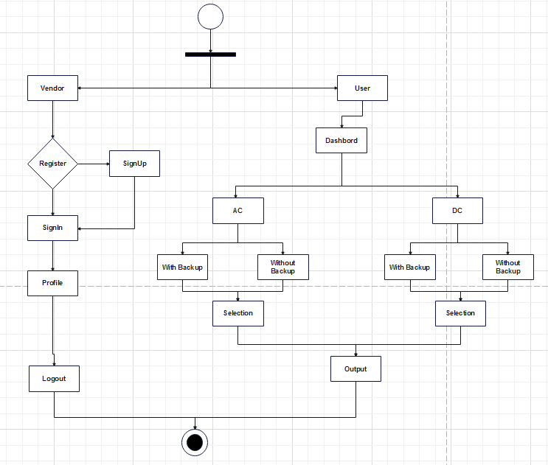

Figure 6.1 Activity Diagram

In the Above Diagram 6.1 shows the activity of Solar Calculations System. First of All, Users and Vendors Signup into the Application and Login the Application. User can select AC or DC System with Backup and Without Backup. Then He will get Result according to their Requirements.

- Use Case Diagram
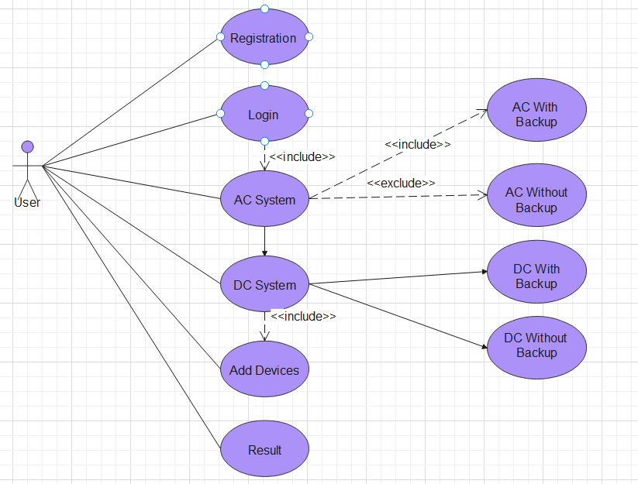

Figure 6.2 Use Case Diagram

In the Above Diagram 6.2 shows various use cases and different type of users the system has and will often be accompanied by other types of diagrams as well.

- Work Flow Diagram

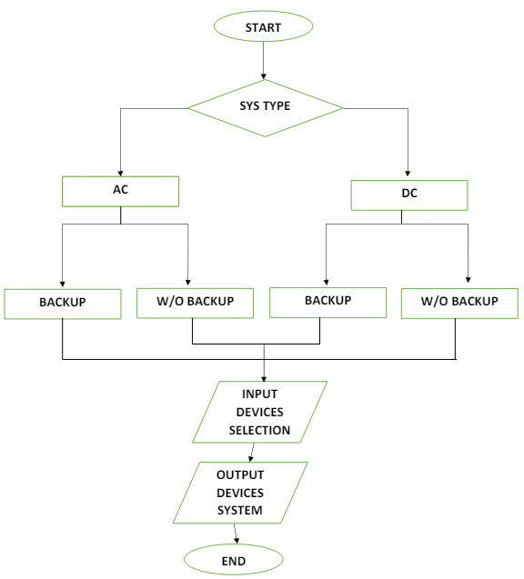
Figure 6.3 Work Flow Diagram
In the Above Work Flow Diagram 6.3, user start in which two types of systems are given which is AC system and DC system, in this AC and DC are also passed through two different stages. With backup and without backup and according to the requirement of the user.

- Data Flow Diagram
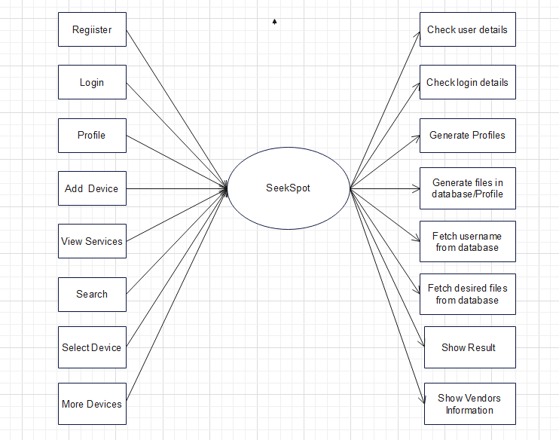

Figure 6.3 Data Flow Diagram

In the above diagram 6.4 which shows the Data flow of solar calculations system how user can register yourself and logged into the application then he will select device option and see more devices through this user can select his data and get the expected result. User can also see vendors information.

- ER Diagram

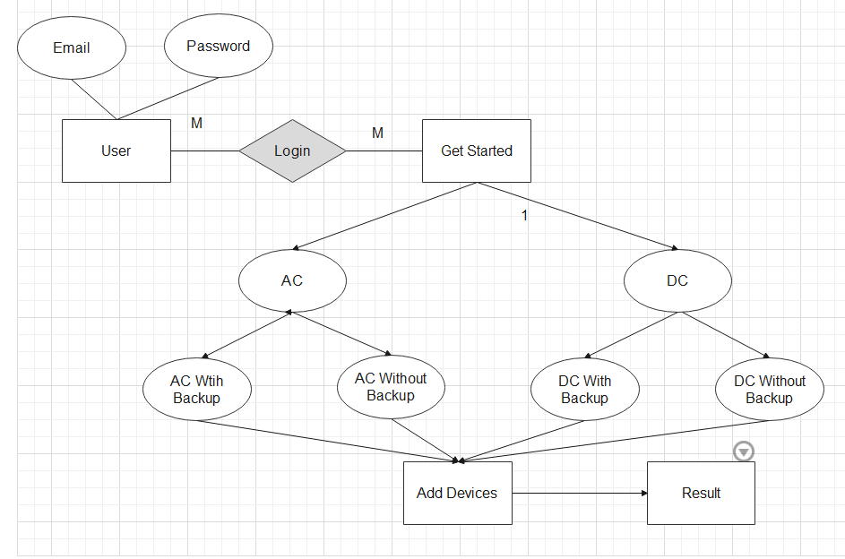

Figure 6.4 ER Diagram

In the above Diagram 6.5 shows the Relations of solar calculations system in which how the relations of users can interact with other many relations.

Chapter 7

IMPLEMENTATION AND TESTING

7.1 Project Management

Project management is about auditioning the information, tools and techniques in the behavior of the project to fulfill project requirements. It is a related collection of the processes of the system that enables the project team to accomplish a successful plan and project.

7.3 Risk Management

Table 7.2 Risk Management

SR. | Designation | Description
1 | Project  Manager | Meeting was held between the team leader and the management for two days to overview the circumstance of all undertakings to control the risk, review the experience assessments for the risks and the endeavour list is Imitated.
2. | Risk Officer | Organized and tested the risk identification and performance.  The project risk list was managed by him.  Information management team of new risk objects, exposure risk decision status to management.
3. | Project  Members  (assigned risk) | A project member was assigned to the new acknowledged risk by the Risk officer; the project member calculated the error, failure and probability for the risk factor and results of that analysis was reported back to Risk Officer. The project member was also responsible for planning and reporting to risk officer.

In the above table 7.2 shows the Project Manager, Risk Officer and Project Members is representing the points as described in the above table.

7.2 Implementation
For the implementation there are four parts as follow
➢ Reviewing the requirement and the tools.
- Details of the creation of the database
➢ Details of the creation of the interfaces.
- Some of the codes are also include for explanations and reviewing user interfaces.

7.2.1 Login
Users can enter into the application through Firebase Phone Number authentication login process which sends the code on the phone number entered by the user. If the user doesn’t have account or never register before he/she will be registered. Users can login to the system by using own Mobile number and sending code again.

7.3 Information Management
The information entered by the user is stored in the Firebase database for mobile application. All the details of the User are stored in Firebase database.

7.3.1 Implementation
For the implementation there are four parts as follow
➢ Reviewing the requirement and the tools.
- Details of the creation of the database
➢ Details of the creation of the interfaces.
- Database connection.
- Some of the codes are also include for explanations and reviewing user interfaces.

Information Management
The information entered by the user is stored in the Firebase database for mobile application. All the details of the User are stored in Firebase database.

7.4 Development

7.4.1 Objectives
- Look at the available tools for developing the application.
- Creation of Firebase database.
- Development of the application on Android Studio.
- Creation of the interfaces and contents of application
- Integration of the application with databases respectively
Testing of the features of the application with each development.

7.5 Tools
We have evaluated different tools and have chosen the most suitable tool as per application requirements. As Android Phones are most suitable for this application to install the API and test the interface of the application. The minimum android version is 5.0 is required. We have used Android Studio for the development of the application.
We have used the best tools and equipment for the development of the project. As Android has the biggest smart phone market. Most Therefore, android application development is the best choice for doing a startup. We have used Firebase authentication service for logging in to the application, Firebase database for the storage of the data entered by user. After the implementation of each module, all of the modules were integrated and then the integrated main module was tested for the detection and correction of the errors.

7.5.1 Software Specifications

Table 7.3 Software Specifications
Software Description | Android Application
Operating Software for Solar Calculations | Android Software 7.0 to 14 (API 23-34)
Tools used for Development | Android Studio
Languages used for Development | Flatter (Dart language)
Database | Firebase

In the above table 7.3 shows the Software Specifications and Android Application in following section:
Tools Used for Development: Android Studio
Android Studio:
- Integrated Development Environment (IDE):
  - Android Studio is the official IDE for Android development, providing tools for designing, coding, debugging, and testing Android applications.
  - Features: It includes an intelligent code editor, a visual layout editor, performance analysis tools, and an emulator for testing applications on virtual devices.
  - Developer Support: Offers extensive support for integrating various libraries, version control, and continuous integration.
Dart Language:
- Dart:
  - Language Used in Flutter: Dart is an object-oriented, class-defined programming language optimized for client-side development.
  - Performance: Compiled to native code for high performance on mobile and desktop, and also supports just-in-time (JIT) compilation for fast development cycles.
  - Modern Features: Includes async/wait for asynchronous programming, a rich standard library, and sound null safety for improved reliability.

7.5.2 Hardware Specifications

Table 7.4 Hardware Specifications
Hardware Specification | Android Application
Ram | 1 Gigabyte  (1 GB)
Processor | 1.6 Gigahertz
Storage | 8 Gigabyte  (8 GB)

In the above table 7.4 shows the hardware specification and android application in following section:
RAM: 1 Gigabyte (1 GB)
RAM (Random Access Memory) is a type of computer memory that is used to store working data and machine code currently in use. For an Android application:
1 GB of RAM indicates that the device can handle basic multitasking and run most apps, but it might struggle with heavy applications or extensive multitasking.
Performance Impact: Applications that require significant memory for data processing, gaming, or multimedia might experience slower performance or might not run as smoothly on a device with only 1 GB of RAM.

Processor: 1.6 Gigahertz
Processor speed is measured in gigahertz (GHz) and determines how many cycles per second the CPU can execute. For a device with:
Storage: 8 Gigabyte (8 GB)
Storage refers to the device’s internal capacity to store the operating system, applications, and user data.
After the implementation and generation of code, testing of that implementation begins. There are several testing tools available to recognize and get rid of the bugs that were comprised during the implementation of the system. Software will categorically suffer variations once it is provided to the end user i.e. user. There can be several reasons of the change. Change could be ensued by giving various unpredictable input values to the system. Moreover, changes in the system could also directly disturb the operations of the system. The testing is ensured to accommodate variations that could happen during the implementation of the system. We have performed various tests during and after the implementation of the system. These tests were performed to confirm that the developed system is working according to the user requirements and is ready to be used. While the project was in completion phase, we took up the activity of testing each individual form and ensured that the collaboration among the various forms is perfect.
- All tests are perceptible to user necessities.
- Tests were scheduled before the beginning of testing.
- To be effective, testing was conducted by assuming ourselves as user

7.6 Testing

7.6.1 Functional or Black Box Testing
In this technique, some of the test circumstances were produced as input conditions that entirely accomplish all of the functional necessities of the system. Black box testing was used to find out the errors in the following classifications:
- Inappropriate or misplaced functions
- Errors in the Interface and Performance of the system
- Data structure errors and errors in accessing the external database
- Errors in the initialization and termination of different functions, classes or parameters.

7.6.2 White Box Testing:
White box testing is performed on the logic of by drawing flow graphs of each module and logical decisions are tested on all the cases of that module. It has been used for the generation of the test cases in the following:

- To ensure that all the independent paths of each module of the system is being executed.
- To execute all the logical decisions according to all conditions or scenarios.
- To execute all loops of the system within the corresponding boundaries.
- To execute internal data structures to ensure validation.

7.6.3 Unit Testing
After the integration of the modules of the system. System was tested to determine the correctness of the system in terms of input, processing and output by the execution of the predesigned test circumstances.
The unit testing was used to test the logic of internal processing and data structures within the corresponding boundaries. Moreover, we kept editing each of the module until each module was completed, corrected and performing according to requirements.

7.7 Test Cases

7.7.1 User Login

Table 1.5 User Login
Test Case ID: | LOGIN_USER_T_1
Version: | 1.0 | Date: | 20th Sep, 2024
Use Case Ref: | User Login
Purpose: | User must be logged in to use SMART PHONE
Environment: | Android 11 LTS, latest version
Pre-Request: | User have to open the Mobile app
Execution Description: | User have to enter his valid email and password to successfully log in to system.
Expected Result: | User Logged in Successfully
Actual Result | User Logged in Successfully.
Pass/Fail | Pass

In the above table 7.5 shows the user login Test case_1. User expected result is logged in successfully and Actual result is logged in successfully.

7.7.2 User Profile
Table 7.6 user profile
Test Case ID: | PROFILE_USER_T_2
Version: | 11 | Date: | 22th Sep, 2024
Use Case Ref: | User Profile
Purpose: | User want to be created his/her profile.
Environment: | Android 11 LTS, latest version
Pre-Request: | User has to open the mobile application and has stable internet connection
Execution Description: | User first have click on Profile, then the User have to fill the required details.
Expected Result: | Profile created Successfully.
Actual Result: | Profile created Successfully.
Pass/Fail | Pass

In the above table 7.6 shows the user profile Test Case_2. User expected result is profile created successfully and Actual result is profile created successfully.

7.7.3 AC System with Backup or without Backup

Table 7.7 AC system with backup or without Backup
Test Case ID: | AC with backup or without backup_T_3
Version: | 11 | Date: | 24th Sep, 2024
Use Case Ref: | User want to know AC system with Backup or without backup
Purpose: | User want to know their calculations
Environment: | Android 11 LTS, latest version
Pre-Request: | User has to open the mobile application and has stable internet connection
Execution Description: | User first have click on the AC system then the User have to fill the details about their requirements
Expected Result: | Select AC system successfully
Actual Result: | Select AC System successfully
Pass/Fail | Pass

In the above table 7.7 shows the AC with backup or without backup Test Case_3 in which user expected result is select AC system successfully and actual result is select AC system successfully.

7.7.4 DC System with Backup or without Backup

Table 7.8 DC system with backup or without Backup
Test Case ID: | DC with backup or without backup_T_4
Version: | 11 | Date: | 24th Sep, 2024
Use Case Ref: | User want to know DC system with Backup or without backup
Purpose: | User want to know their calculations
Environment: | Android 11 LTS, latest version
Pre-Request: | User has to open the mobile application and has stable internet connection
Execution Description: | User first have click on the DC system then the User have to fill the details about their requirements
Expected Result: | Select DC system successfully
Actual Result: | Select DC System successfully
Pass/Fail | Pass

In the above table 7.8 shows the DC with backup or without backup Test case_4 in which user expected result is select DC system successfully and Actual result is select DC system successfully.

Test-Case Results

Table 7.9 Test Case Results
Test Case Number | Expected Result | Actual Result
TC-01 | Pass | Passed
TC-02 | Pass | Passed
TC-03 | Pass | Passed
TC-04 | Pass | Passed

Chapter 8

RESULTS AND DISCUSSION

Splash screen



Figure 8.1 Splash Screen
In the above Figure 8.1 shows the Welcome Screen to the User Interaction

Sign Up
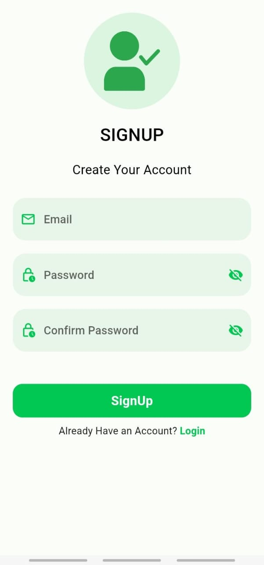

Figure 8.2 Sign up Screen
In the above Figure 8.2 shows the signup screen to the user to sign up into the application.

Login

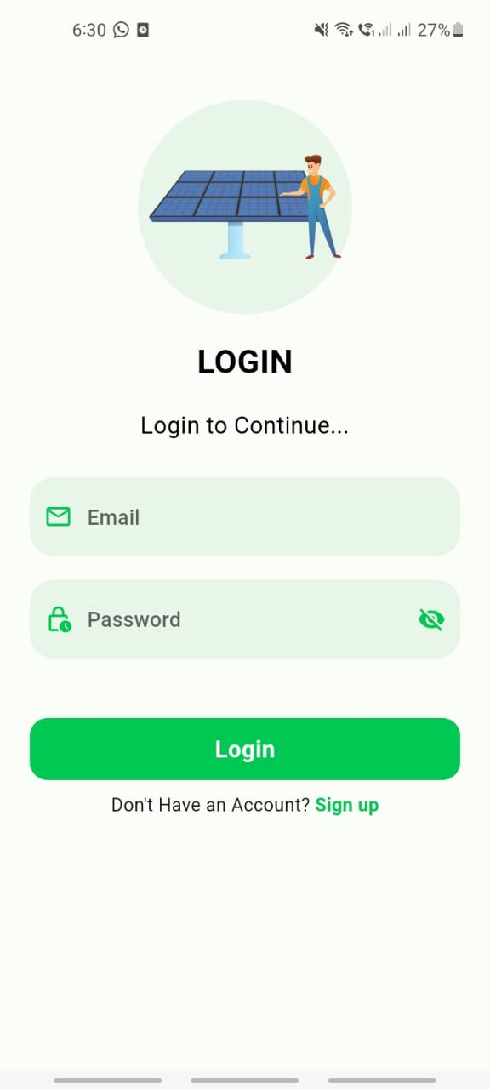

Figure 5.3 Login Screen
In the above Figure 8.3 shows the Login Screen to the User After the Signup.

Home Screen

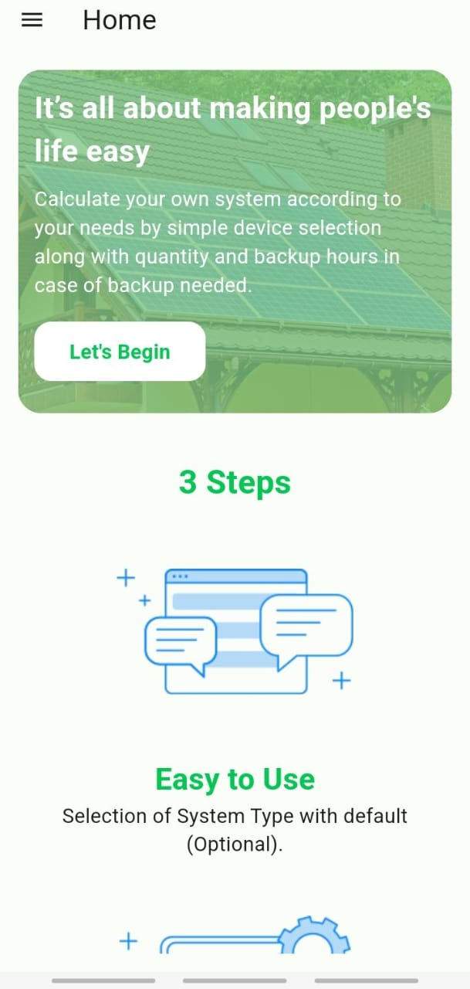

Figure 8.4 Home Screen
In the above Figure 8.4 shows the Home Screen to the User After Login and Guide the User About Application.

Get Started Screen

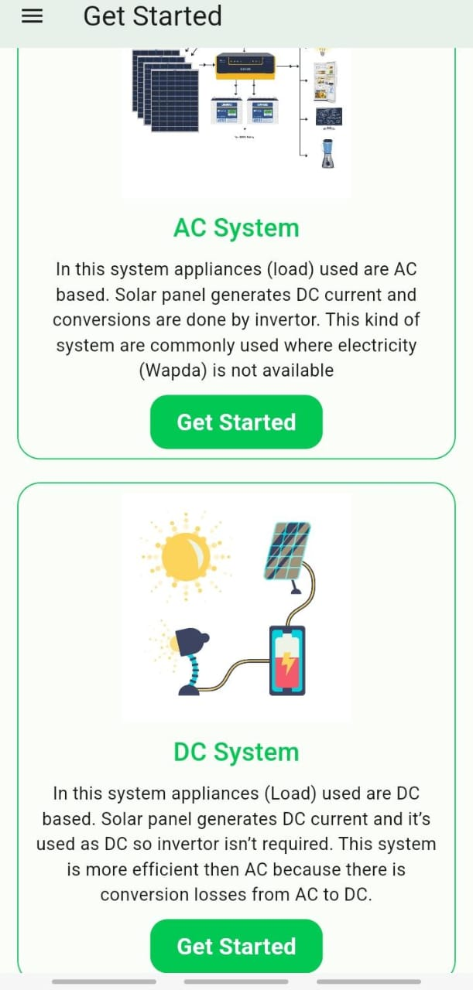
Figure 8.5 Get Started Screen
In the above Figure 8.5 shows the Get started screen for the selection of AC and DC system.

Choose Backup Screen

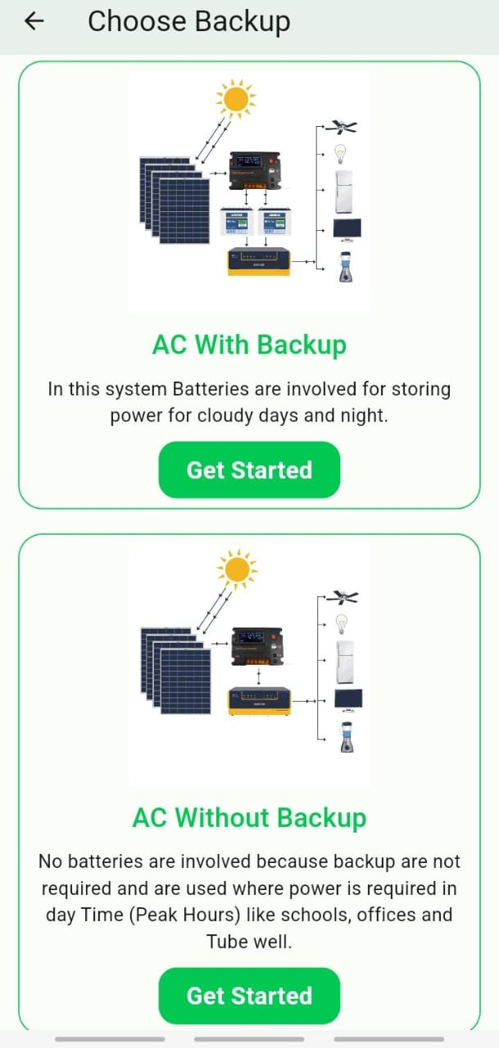

Figure 8.6 Choose Backup

In the above Figure 8.6 shows the Choose backup AC with backup or without backup.

Add Device Screen

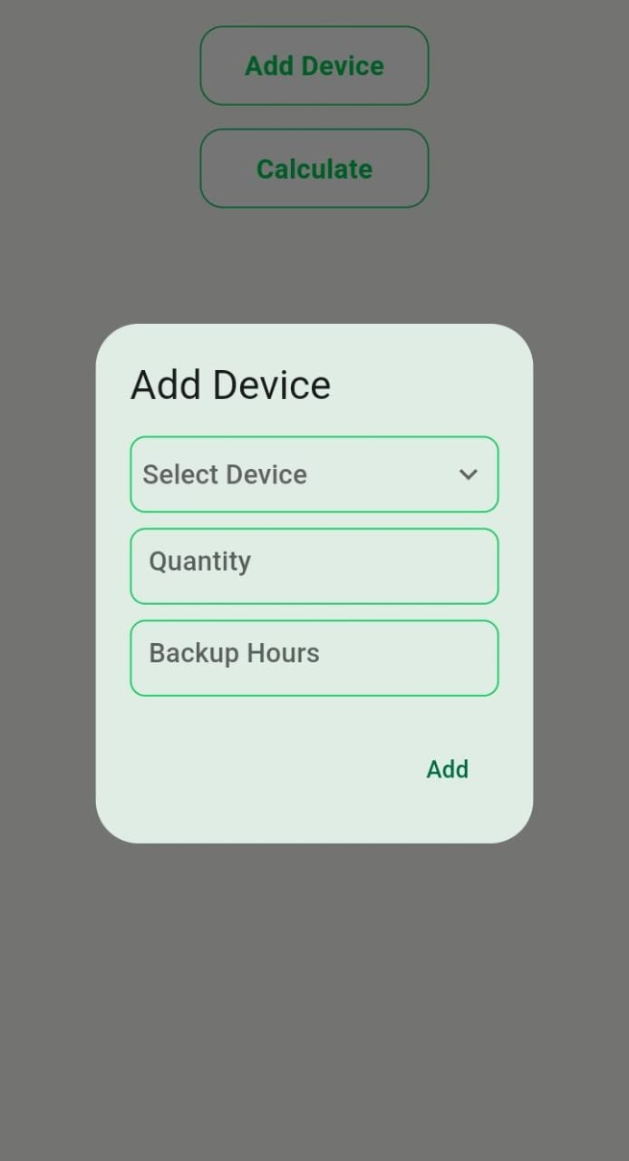

Figure 8.7 Add Device
In the above Figure 8.7 shows the devices option which one selected by the user.

Result Screen

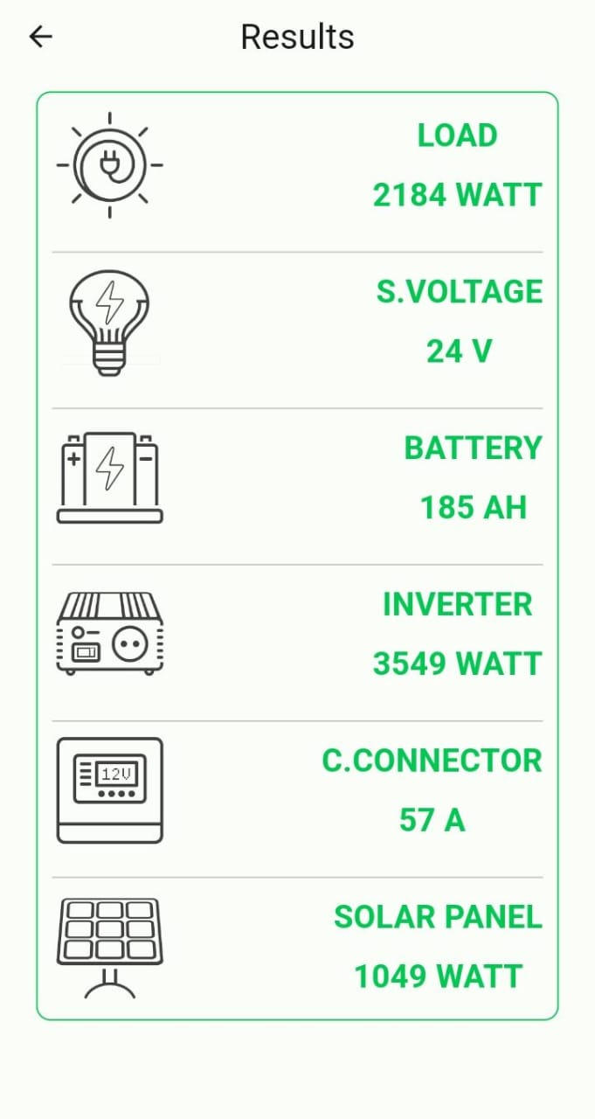

Figure 8.8 Result Screen
In the above Figure 8.8 shows the result screen for the user expected result.

Chapter 9

CONCLUSION AND FUTURE WORK
Solar power systems have emerged as a critical component in the transition to renewable energy sources, offering numerous benefits such as reducing greenhouse gas emissions, decreasing dependency on fossil fuels, and providing energy security. The detailed design and interaction of various subsystems within a solar power system—solar panels, mounting systems, inverters, battery storage, charge controllers, monitoring systems, grid integration, and protection mechanisms—are essential for optimizing performance and reliability. The future of solar power is bright, with continuous advancements in technology and increasing global commitment to renewable energy. by way of specializing in innovation, integration, and sustainability, solar power structures can play a pivotal function in accomplishing a sustainable strength destiny. persevered studies, supportive regulations, and public engagement are crucial to overcoming modern-day challenges and unlocking the full capability of solar power.
The development of programs for solar calculations has notably contributed to the efficiency and optimization of solar power systems. these packages permit specific calculations for sun panel positioning, strength yield predictions, and system sizing, thereby improving the overall overall performance of solar installations. The accurate and user-pleasant nature of those gear has made sun electricity greater handy and attractive to both purchasers and industry professionals.
looking in advance, the future work in this area have to attention on integrating superior technologies inclusive of synthetic intelligence and machine mastering to in addition refine and automate solar calculations. enhancements in actual-time information analysis and predictive maintenance can make sure extra reliable and efficient solar energy systems. moreover, expanding the skills of those programs to comprise rising technologies like bifacial sun panels and floating sun farms could be vital.
furthermore, fostering extra interoperability with different renewable electricity sources and power storage structures may be important for growing extra sturdy and resilient energy networks. continuous upgrades in consumer interface design and educational sources will also be necessary to ensure those gear stay on hand to a wide target audience. through addressing those regions, the continuing evolution of sun calculation programs can play a pivotal position in advancing the global adoption of sun energy and attaining sustainable electricity desires.

REFERENCES
[1] M. R. Shaikh, S. Shaikh, S. B. Waghmare, S. Labade, and A. Tekale, "A review paper on electricity generation from solar energy," Int. J. Res. Appl. Sci. Eng. Technol., vol. 887, 2017, Doi: 10.22214/ijraset.2017.9272, (2014)
[2] J. P. Dunlop, Photovoltaic Systems. American Technical Publishers, Incorporated, (2012).
[3] Aruban, A & Shah…... etc. "Clean energy," [Online]. Available: https://www.cleanenergyauthority.com/solar-energy-resources/3-types-of-residential-solar-electric-power-systems. [Accessed: Aug. 12, 2024].
[4] Malavolta, S. Ruberto, T. Soru, and V. Terragni, "Mobile apps in the Google Play Store: An exploratory investigation," in Proc. Mobile Soft, 2015, Doi: 10.1109/Mobile Soft. (2015).
[5] R. Mahesh Babu, M. B. Kumar, R. Manoharan, M. Somasundaram, and K. Sp, "Portability of mobile applications using PhoneGap: A case study," in Proc. IC, 2012, pp. 1-6, Doi: 10.1049/ice. (2012).
[6] Su, S., Nguyen, T “Solar Energy Research Institute (SERI)”, University Kebangsaan Malaysia, 43600 Bangi, Malaysia. (2019)
[7] Al-Musab Technical College, Al-Furat Al-Awsat Technical University, 51009 Babylon, Iraq, (2008).

